3GPP TSG RAN WG1 #125 R1- 2604233
Dalian, China, May. 18th ~ 22th, 2026
Agenda Item: 10.8.2
Source: Lenovo
Title: On the aspects of communication and sensing integration
Document for: Discussion and decision

Introduction
The new study item on 6G Radio was approved in RAN#108 [10], where the study on sensing was agreed with a wide scope of potentially supporting different sensing modes, use-cases/target types, as well as sensing-specific adjustment/optimization of radio signals and procedures. In RAN1#124-bis meeting, initial agreements have been made on the general study directions of sensing reference signal (RS), measurement framework, and sensing-assisted communications. Furthermore, the scope for next-step discussions is identified as following [11]:
Plan for RAN1 #125 [11]
focus on key design choices with proper justification.
- Usage scenarios for sensing assisted communication.
Note: this doesn’t mean we want to directly specify anything. We need RAN1 views on communication assistance which is required by RAN. To justify a usage scenario, either evaluation (10.8.1) or analysis can be considered.
Note: after clarification on the usage scenarios, it is possible that they are merged with object detection/tracking in respective discussions.
- RS design
  - Please elaborate designs on sensing RS especially the RE patterns.
  - Please provide evaluations/analysis.
- Measurement/report
  - Measurement definitions/levels for TRP-side and UE-side measurements, taking into account the impact of non-ideal factors.
  - Views on key issues of measurement reporting mechanisms.
- Based on discussions in this meeting (though no agreements yet), the inputs on the following aspects can be considered which is up to each company.
  - Resource allocation/multiplexing
  - Phase continuity within a CPI
  - Beam related sensing operations
  - Interference handling
  - Power control
  - Timing advance
  - Sensing Tx/Rx node selection, if any, from RAN1 perspective
  - Start/end/activation/deactivation of sensing operations, if any, from RAN1 perspective

In this document, we provide our views on the related aspects for integration with communication, including views on sensing reference signal, integration of sensing and communication from the perspective of coexistence and resource multiplexing, beam related sensing operations, interference handling, sensing-assistance (e.g., sensing-assisted communication enhancements), as well as communication assisted sensing perspective.

General Considerations
Re-use of communication operations
The integrated sensing and communication is envisioned to facilitate radio sensing capabilities while utilizing communication system infrastructure which are primarily optimized for delivering legacy communication services. While sensing operation is expected to provide new capabilities and value generation mechanisms, there is a great motivation to align the physical layer operation and requirements of sensing to that of the communication system, given the inherent synergy (e.g., the same signal can be used for joint sensing and communication purposes), design & implementation simplicity (e.g., reduced need to specification and implementation of additional sensing-specific features), as well as communication-centric prioritization of the system behaviour (e.g., the negative impact on the communication performance due to sensing coexistence is not motivated) all of which improves the operator deployability of such features. As such, it is desirable that the sensing operation re-uses, to the extent possible, the underlying communication entities, signals and procedures, wherein the sensing specific enhancements and optimization are introduced when necessary and justified.
Observation 1. There is a great motivation to align the physical layer operation and requirements of sensing to that of the communication system, given the inherent synergy, design & implementation simplicity, as well as communication centric prioritization of the system behaviour.
Proposal 1. RAN1 to consider a sensing operation that re-uses, to the extent possible, the underlying communication entities, signals and procedures, wherein the sensing specific enhancements and optimization are introduced when necessary and justified.
Identified sensing modes
The radio sensing measurements can be implemented via different combinations of the entities performing sensing transmission and reception. So far, six sensing modes are identified and expected to be supported for the 6GR study, including TRP-monostatic, TRP-TRP bistatic, TRP-UE bistatic, UE-TRP bistatic, UE-UE bistatic and UE-monostatic sensing modes. Moreover, a multi-static sensing mode can be also realized by the combination of two or more of the above-mentioned modes, wherein the transmitted sensing signal can be received/measured by multiple TRP/UE radio nodes.
Nevertheless, different sensing modes imply highly different physical layer operation and limitations, as well as the integration aspects with communication, wherein the measurement process involves considerations of different radio capabilities (e.g., for a monostatic vs. bistatic operation), signal transmission (supported bandwidth and phase coherence requirements for UE based vs TRP based sensing), and measurement processing and reporting capability (e.g., limitation of over-the-air reporting for the modes with UE as measurement node). As such, it is of interest to consider the requirements and physical layer considerations for integration of sensing and communication, separately for different sensing modes.
Observation 2. Different sensing modes imply different physical layer operation and limitations, as well as the integration aspects with communication, wherein the measurement process involves considerations of different radio capabilities, signal transmission, and measurement processing and reporting capability.
Proposal 2. Consider the physical layer aspects for integration of sensing and communication, separately for different sensing modes
UE impact
As part of the 5GA ISAC study, it is assumed that the sensing operation shall lead to no UE impact, both to maintain the UE behaviour as previously developed, as well as to limited available additional study/specification and implementation efforts. Nevertheless, this assumption is highly restrictive and will be reconsidered at least for the following cases. Firstly, as clarified in the considered sensing modes for the 6GR sensing study, the UE-involvement can be envisioned in the sensing transmission, reception and measurement process, substantially expanding the available/possible sensory capability available to the system compared to that of the 5GA assumptions. Secondly, a UE may act as a node defining the sensing scenario, e.g., the sensing area of a “collision avoidance” use-case can be defined relative to a UE and dependent on the said UE’s mobility pattern. And thirdly, the UE may be attached to a sensing object which is of interest for sensing, in which case, the synergy between the UE legacy operations (e.g., communication) and the sensing of the attached passive object can be utilized for a joint optimization of sensing, communication and positioning performance. As such, the integration of sensing into the traditional services and system operations can be optimized, taking into account combination of the abovementioned scenarios. RAN1#124bis explicitly endorsed UE-side measurement and UE-originated measurement reporting (Options 1A/1B in the agreed measurement-report agreement). For 6G ISAC, UE involvement is therefore in scope from the start, and therefore is a need to consider below the three distinct UE involvement types.
Observation 3. The involvement of UE as part of a sensing scenario is envisioned, at least considering UE operation as a sensing Tx/Rx or measurement node, as a node relatively defining the sensing area (e.g., as center of a sensing area), and the UE attached/co-located with a sensing target object (e.g., a vehicle UE attached to a vehicle body to be sensed).
Proposal 3. Consider at least the following three UE involvement for integration of sensing with other system operations and services (communication, positioning)
- UE as a sensing Tx/Rx or measurement node
- UE as a defining node of a sensing area
- UE as an attached connected device to a sensing target object

Aspects of sensing integration

Reference signal for sensing
In RAN1#124-bis, it is agreed that CP-OFDM waveform processing to be a starting point of further potential enhancements and evaluations for ISAC, which motivates study of OFDM-based reference signal (RS) design and potential enhancements for ISAC.
Agreement
CP-OFDM waveform as defined for 6GR is the starting point for 6G ISAC waveform study.
Study on enhancements on CP-OFDM or other waveforms is not precluded.
Agreement
CP-OFDM is used as the benchmark for evaluating the benefits of sensing waveforms.

From the perspective of sensing RS design, it is agreed [Appendix B, Agreement#1] to consider re-use and/or enhancements to the communication-specific RS, as well as a dedicated sensing RS with no design restriction. The dedicated sensing RS can be interpreted as an RS with a dedicated design for the sensing feature, without necessary compatibility to the communication RS structure and/or communication re-use. As an RS design principle for ISAC, it is hence motivated to consider enhancements for sensing RS and/or dedicated sensing RS separately for the cases when the same communication resource (e.g., symbol) is re-used for both sensing and communication purposes, or when the sensing RS is assigned with dedicated time-domain resource. In particular, the former imposes additional design considerations on the RS design to facilitate co-existence and resource multiplexing with the communication signals, whereas the latter introduces additional freedom for sensing-specific optimizations.
Proposal 4. RAN1 to study sensing-specific reference signal design separately for the symbols dedicated to sensing, as reserved/dedicated sensing resource, and symbols utilized jointly for sensing and communication purposes.
Pulse signal
Both Pulse-Wave (PW)-like and Continuous-Wave (CW)-like sensing signals have been proposed as sensing signal candidates for the mono-static and bi-static sensing modes. In particular, the PW signal has the potential to utilize delay differences of the sensing path and the direct or leakage path (containing prohibitively large energy), in order to separate the signal reception in the time domain, thereby counteracting the limited dynamic range challenge at the sensing Rx node [12].
When the sensing signal is transmitted within a dedicated resource/symbol, the pulse-signal can be shaped in time domain via implementation according to a time-domain pulse-shape, where the pulse width and off-periods can be adjusted to the sensing scenario, e.g., the expected target path and direct path delays and pathloss. On the other hand, when the sensing signal is intended to co-exist with communication or other RS transmissions within the same symbol, the pulse-shape signal shall be generated as part of the waveform processing used for communication. As such, it is motivated to study the pulse-shape generation compliant with OFDM waveform processing, wherein the communication and sensing resources are multiplexed within the same symbol. One example implementation is depicted in Figure 1 below.
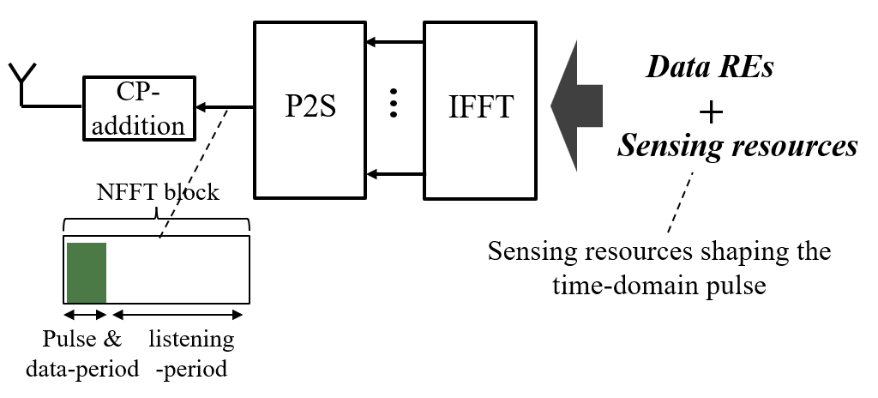
Figure 1 An illustration of pulse-signal shaping and shared with communication data in the same OFDM symbol based on IFFT processing
Observation 4. Generation of pulse-signal for sensing is of interest for resolving limitations of dynamic range, when the target channel is of a substantial delay difference as well as lower energy compared to the direct/background paths
Proposal 5. RAN1 to study OFDM-based pulse-signal generation for sensing from the perspective of resource multiplexing and communication coexistence, both within dedicated sensing symbols and within symbols jointly used for data transmission
Comb RS pattern for sub-symbol periodicity
In order to facilitate a flexible CP expansion framework while jointly improving resilience to doppler impairments at the receiver, an OFDM-based sensing signal can be shaped to show sub-symbol periodicity, by restricting the non-zero input subcarriers to the IFFT block at certain locations. This can be realized by following a comb-C structure including the DC subcarrier, leading to the sub-symbol repetition in time-domain of N/C, with N being the NFFT length. An example such property of a sensing symbol is depicted in the below figure.
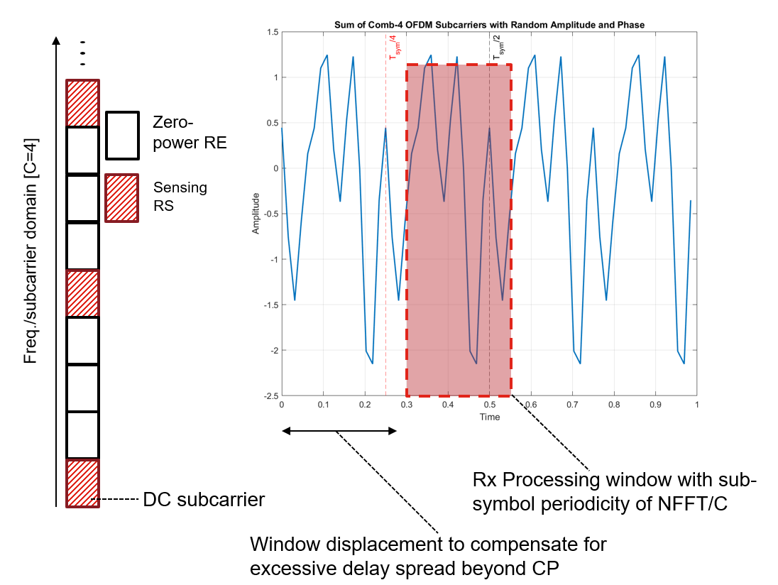Figure 2 An illustration of sub-symbol periodicity, based on comb C=4 structure for a symbol carrying sensing signal.
Please note that with the above, two challenges are addressed at the same time. Firstly, a larger effective CP is generated by adjusting the Rx processing window to the expected maximum delay of the sensing paths, utilizing the produced sub-symbol periodicity, i.e., due to the sub-symbol periodicity, without inserting larger CP in the frame structure, thereby avoiding the energy loss with larger CP. Secondly, a higher doppler resilience is achieved by allowing multiple short measurement window sizes, i.e., N/C, for which the cyclic property is preserved.
Proposal 6. RAN1 to study OFDM-based sensing signal generation according to a Comb structure with intra-symbol cyclic property to achieve larger CP behaviour.
Multi-resolution enhancement
Unlike the reference signals intended for channel estimation or demodulation, the sensing RS is expected to span across a large time duration and bandwidth, with the intention of achieving a high delay-doppler resolution and estimation accuracy. However, the large bandwidth and time span of the sensing signal, together with the scenario-dependent maximum unambiguous delay and doppler value, will result in a rather dense resource pattern. When the reference signal assumes a uniform resource pattern, this leads to a high total sensing overhead, i.e., a large time duration (due to doppler resolution and SNR boost) with short uniform periodicity (due to doppler ambiguity). In order to reduce the sensing signal overhead while maintaining both delay/doppler resolution and ambiguity, it is motivated to consider a non-uniformly distributed resource pattern, wherein the sensing resources across time and/or frequency include the periodicity of inter-RE/symbol distances. From the pattern generation perspective, a non-uniform RS pattern can be both generated by defining natively non-uniform distribution, or via combining two or more RSs each with uniform time-frequency distribution.
Towards this end, few examples for non-uniform (or multi-resolution) resource pattern across time and/or frequency is depicted in the below figure.

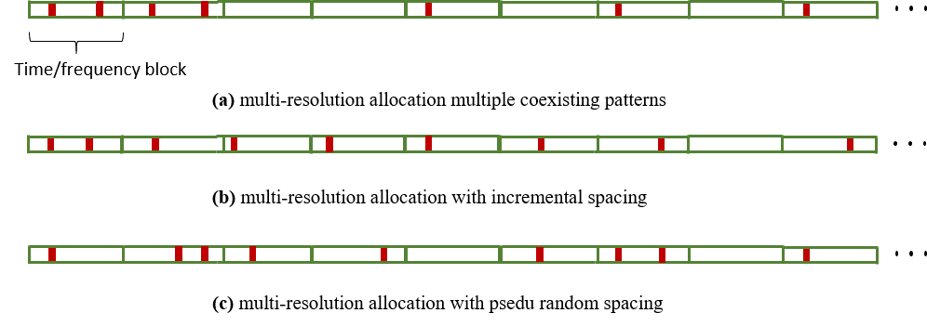

Figure 2. Few example implementations of non-uniform RS resource pattern
Observation 5. The large sensing observation time, required for high resolution doppler estimation for path separation, together with the needed pulse transmission interval for keeping doppler estimation within an unambiguous region, when assuming a uniform resource pattern, leads to a large resource overhead in the time-domain
Observation 6. Similarly, the large sensing signal bandwidth, required for high accuracy delay estimation, together with the needed maximum inter-RE separation for keeping delay estimation within an unambiguous region, when assuming a uniform resource pattern, leads to a large resource overhead in the frequency domain
Proposal 7. RAN1 to study non-uniform resource patterns, in both time and frequency for a sensing RS including at least the following methods
Defining native time-frequency patterns supporting multi-resolution behaviour
Generating a sensing RS time-frequency resource pattern as a combination of multiple existing RS patterns
Reuse of existing communication RS, e.g., CSI-RS, for sensing
In RAN1#124bis, it is agreed to consider aspects of sensing performance, resource overhead and impact to communication for three different possibilities of RS transmissions for sensing. This includes a full re-use of the existing/communication RS, improvements to the communication RS for necessary sensing enhancements, as well as a dedicated sensing RS [Appendix B, Agreement#1]
Agreement:

- On RS for ISAC, study at least the following aspects, considering sensing performance, resource overhead and impact to communication
  - RS for communication is reused for sensing
  - Enhanced RS for sensing, taking reuse of RS for communication as starting point
    - Note: Part of or all of the RS may be used for communication purpose, and it does not mean the final decision on whether the enhanced RS is used for communication purpose is to be made in this agenda.
  - Dedicated RS for sensing

Please note that the above three study directions both relate to the logic of the sensing RS design (i.e., whether or not considering the existing communication RS structure as a design constraint), as well as the usage scenario, wherein the sensing and communication related measurements can use the same signal resource or to be conducted via separate/independent resources. For the sensing modes involving TRP as a sensing Tx, e.g., TRP-UE bistatic sensing mode, CSI-RS/TRS configurations for DL can be considered as a starting point, due to the wide deployment, large bandwidth and relative configuration flexibility. Nevertheless, CSI-RS/TRS are originally designed to support channel estimation and time/frequency tracking over the typical communication coherence window and not for sensing or positioning measurements, where timing/Doppler ambiguity, multi-TRP resource pairing and effective bandwidth may appear as limiting factor in the achievable performance. As such, it is motivated to consider the CSI-RS/TRS as a starting point for the sensing RS design and study necessary enhancements.
Observation 7. For the sensing modes including TRP as a sensing Tx node, pure reuse of existing CSI-RS/TRS may be insufficient for high performance sensing/positioning use cases at least due to limited time-domain density.
Proposal 8. For the sensing modes including TRP as a sensing Tx node, consider CSI-RS and TRS as the basis for sensing RS design, at least considering enhancements in time-domain behavior (e.g., density).

Resource multiplexing
As it has been observed from [6], for a UMa scenario with ISD = 500m, the link coverage for a monostatic TRP for UAV sensing extends beyond the assumed cell boundaries, while limited by the environment impacts such as target LOS/NLOS condition, target placement within the antenna radiation pattern (e.g., elevation angle of target path), as well as the background clutter and mobility, appearing as sources of impairments. This is evident from the cases where the optimally “selected” TRP is not the closest TRP to a specific target area. This emphasizes the significance of the impacts of sensing signal within and beyond cell boundary. As such, the mutual interference of sensing signals and communication signals, including interference of one sensing signal on another sensing signal or a communication signal, as well the interference from the communication signal transmissions to the sensing operation, needs to be considered and controlled.
Towards this end, the multiplexing schemes among the sensing signals and/or communication signals transmitted by one or multiple sensing entities needs to be considered, at least via a combination of one or more of the TDM, FDM, SDM, CDM schemes.
Observation 8. For a UMa scenario with ISD = 500m, the link coverage for a monostatic TRP for UAV sensing extends beyond the assumed cell boundaries, and hence the mutual impact of sensing signal to other sensing signal and/or communication signals needs to be understood and controlled.
Proposal 9. RAN1 to consider multiplexing schemes among the sensing signals and/or communication signals transmitted by one or multiple sensing entities needs to be considered, at least via a combination of one or more of the TDM, FDM, SDM, CDM schemes.
For a sensing RS with multiple ports and/or multiple transmission radio nodes, it is of interest to structure the CDM groups to reduce the impact of impairments and interference. As discussed before, a sensing path may be associated to a large propagation delay and/or doppler shift, leading to evolving phase per-RE measurement across time and/or frequency. This, in part, invalidates the logic of the CDM groups relying on TD-OCC and/or FD-OCC, assuming the underlying channel remain constant across multiple time-domain symbols and/or frequency domain REs. As such, at least for the scenarios with expected large delay and/or mobility, it is of interest to introduce CDM groups with flexible cover-code configurations, at least supporting TD-OCC length = 1 (for high doppler scenarios), FD-OCC length = 1 (for large propagation delay scenarios) and TD-OCC length = 1, FD-OCC length = 1 (for jointly larger doppler and propagation delay). As such, the multiplexing of the ports within a CDM group can be facilitated in the sequence domain.
Proposal 10. RAN1 to consider multi-port sensing RS multiplexing with flexible cover-code configurations, at least supporting TD-OCC length = 1 (for high doppler scenarios), FD-OCC length = 1 (for large propagation delay scenarios) and TD-OCC length = 1, FD-OCC length = 1 (for jointly larger doppler and propagation delay).
In majority of the envisioned sensing operations, the sensing measurement and clutter suppression relies on the target movement pattern, by processing the observed channel/path in the doppler domain. A large sensing time is hence reported, e.g., [6], to enable a doppler domain filtering for clutter suppression.
Nevertheless, a large sensing coherent processing interval also leads to a large per-task sensing overhead (e.g., in terms of the total sensing REs resources consumed) while leading to a large SNR boost due to the coherence combining. In one example scenario, for an always-on signal with Fc = 6 GHz and BW = 100MHz, SCS= 30kHz, a sensing time-window of utilized for sensing of a human movement with 3km/h speed, a sensing time duration of 300 msec is needed to reach speed resolution equivalent to %10 of the typical human speed. Subsequently, this leads to 72-75dB of coherent processing gain, assuming an always-on signal at all available REs.
The above example motivates the use of low-power sensing signal, superimposed with the communication signals and/or other RSs in the power domain without orthogonality restrictions. In such a case, sensing processing relies on the large coherence bandwidth over the sensing time window to recover the need sensing signal strength, while remaining harmless to the superimposed communication resources, due to the substantially lower power.
The feasibility and optimal strategy for sensing signal superimposition can be use-case and scenario dependent, with potentially larger gain with scenarios with lower mobility and targets with larger RCS. Examples of such superimposition strategy has been depicted in Figure 3, including cases (a) with the full resource sensing and data superimposition, wherein the sensing signal is present in all available transmission resources (b) superimposition with protected data or non-sensing RS, (c) a mixed superimposed and non-superimposed transmission.
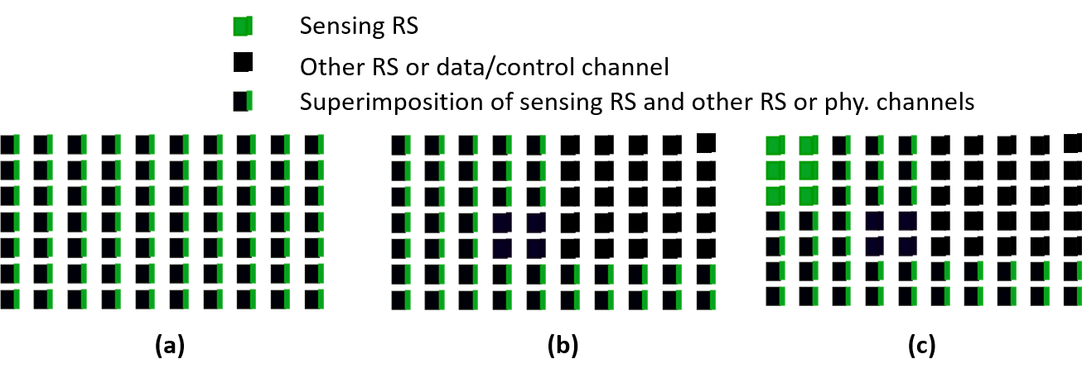
Figure 3. Examples of power domain sensing signal superimposition, (a) the full resource superimposition, (b) superimposition with protected data or non-sensing RS, (c) a mixed superimposed and non-superimposed transmission

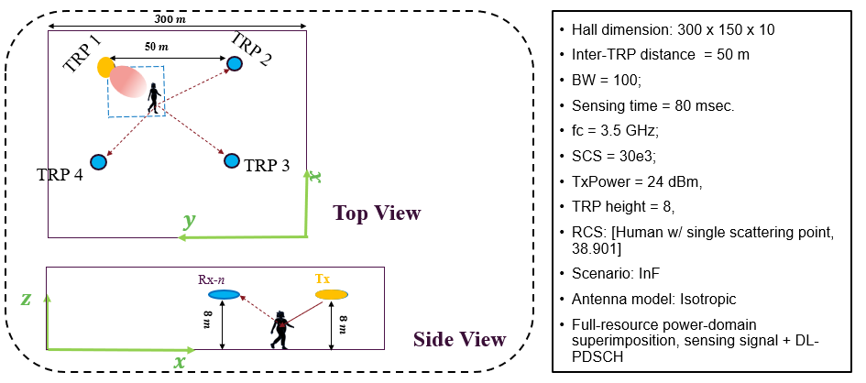
Figure 4 An example scenario for sensing signal superimposition, DL PDSCH superimposed in power domain with sensing signal across all allocated REs. A selected TRP performs sensing Rx measurements in LOS condition to the target, assuming a perfect clutter suppression at the receiver.

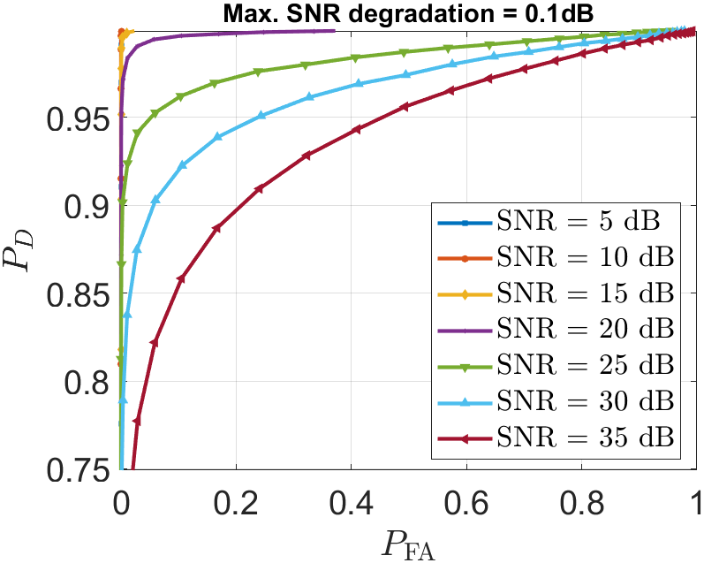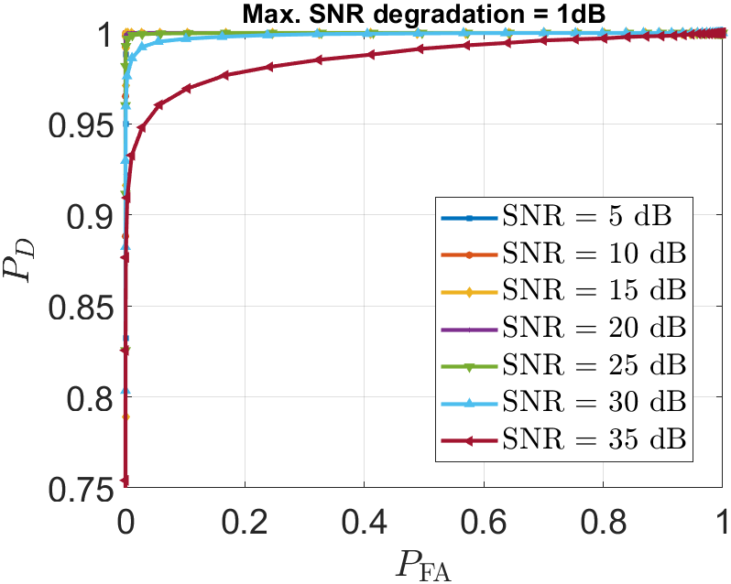
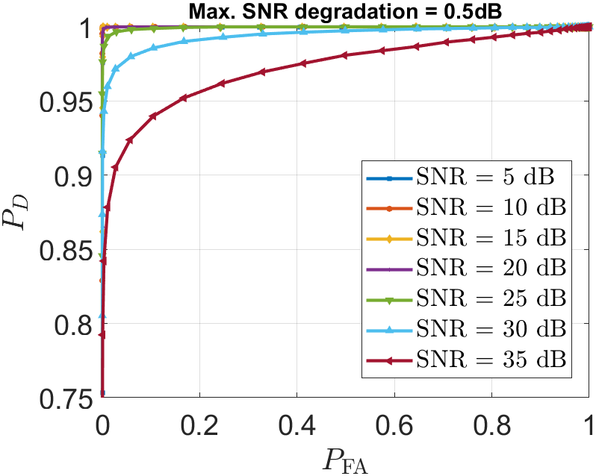
Figure 5 An example scenario for sensing signal superimposition, DL PDSCH superimposed in power domain with sensing signal across all allocated REs. The sensing signal power is limited, for a given link SNR, such that the experienced link SNR is not degraded above a Max SNR degradation level, leading to different sensing performance depending on communication link SNR and the allowed SNR degradation.
In Figure 5, an example scenario for power-domain sensing signal superimposition is depicted, wherein the sensing signal is added to the DL PDSCH signal without (time/freq./code) orthogonality limitation. A selected TRP performs sensing Rx measurements in LOS condition to the target, assuming a perfect clutter suppression at the receiver. Moreover, it is considered that the sensing signal power is limited according to a PDSCH link SNR and a given maximum SNR degradation. For instance, for a Tx power of 24 dBm, when a scheduled PDSCH link enjoys SNR = 10 dB, then the allowed transmission power of the sensing signal is 8.1 dBm, for a maximum tolerable SNR degradation of 1 dB, and -2.3 dBm for a maximum tolerable SNR degradation of 0.1 dB. Please note that, the substantially reduced transmission power is compensated, given the scenario with relatively short distances, as well as the long sensing time (leading to a large coherence combining gain at the sensing receiver), recovering sensing performance to an acceptable level.
Observation 9. Due to a large sensing time needed to obtain sufficient doppler resolution, the sensing signal may be spread over a large volume of transmission resources, with a reduced sensing transmission power, facilitating power-domain superimposed transmission with data
Proposal 11. RAN1 to consider the scenarios and methods to facilitate power domain superimposed sensing transmission to reduce time/frequency resource overhead for sensing
Similar to the above, it is of interest to facilitate superimposition of the sensing RS across multiple ports, avoiding additional overhead for multi-port/beam transmissions. This includes CDM group with non-orthogonal cover-codes as well as sequence domain superimposition. This is particularly motivated, given the large number of repetitions of a sensing signal within a CPI, which helps to de-correlate/orthogonalize different sensing RS ports over the full measurement process.
Proposal 12. RAN1 to consider non-orthogonal multi-port sensing RS multiplexing methods, including non-orthogonal cover-codes as well as sequence domain superimposition for sensing

Communication-assisted sensing

Opportunistic proximity sensing
As part of the object detection and tracking class of sensing use-cases, the scenarios of proximity sensing including a sensing area within a proximity of a UE device is of interest, e.g., for collision avoidance as well as the monitoring (health/presence) use-cases [TR 22.837, UC 8,12,15,31]. In such scenarios, the UE device has the advantage of the favourable relative position to the target, thereby the potential to enhance the effective sensing SNR of the desired (sensing) reflective path.
An example of such comparison is given in Figure 6, wherein the Sensing path SNR (SSNR) is depicted for the TRP-TRP and TRP-UE sensing modes, assuming a collision avoidance use-case in the proximity of a UE UAV at the height of 200 meters. The effective SSNR is evaluated for different distances between the UE UAV and a sensing target (a bird or another UAV with potential for collision with the said UE UAV). It is understood that a better power/SSNR of the sensing path associated with a target facilitates better separation from the background/clutter paths, as well as a higher resolution delay/doppler estimation.
From the below Figure 6, it is observed that the effective SSNR can be improved by incorporating measurements conducted by a the UE UAV as a UE sensing Tx/Rx node for monitoring/sensing the sensing area in its close proximity, e.g., for the purpose of collision avoidance in a close proximity of the said UE UAV. It is further verified that the UE UAV measurement is more beneficial as the target-UE distance becomes shorter.
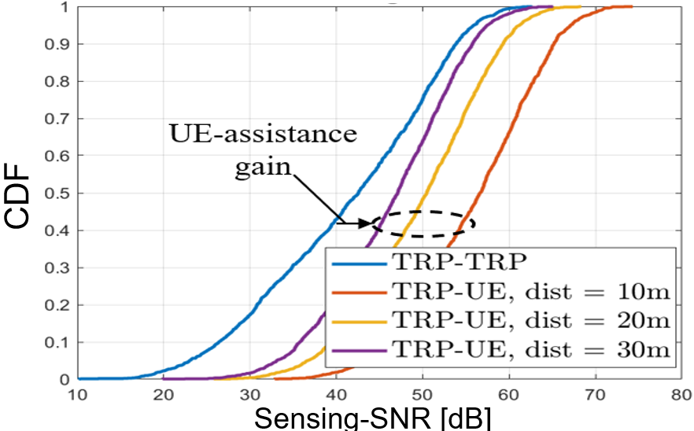
Figure 6. Sensing path SNR (SSNR) for TRP-TRP and TRP-UE (UAV) sensing modes, assuming a UAV at height 200 meters, UMA-AV deployment with ISD = 500m, and dist. represents the distance of the sensing target to the UAV.
The above SSNR improvement illustrates the potential for gainful use of the TRP-UE and/or UE-TRP sensing modes, enjoying the short target-sensing entity pathloss from the UE side. Moreover, the associated DL or UL physical channels, when present, can be opportunistically used to obtain sensing measurements without additional signal overhead, which can be used to complement or improve the sensing measurements obtained via other sensing modes and/or sensing-specific transmissions. In order to realize this gain, needed UE behaviour needs to be studied and developed to utilize the received data for sensing, given the data randomness and non-optimal signal structure for sensing. As such, the feasibility and potential enhancements to the sensing measurements shall be studied, e.g., for optimizing the transmission characteristics of the said UL/DL channels adjusted for a proximity sensing operation, at least from the perspective of the resource pattern, UE measurement behaviour and MIMO operation.
Observation 10. The associated DL or UL physical channels to a UE, when present, can be opportunistically used to obtain sensing measurements for proximity sensing use-cases.
Proposal 13. RAN1 to study feasibility and potential enhancements to the sensing measurements based on physical data or control channels for proximity sensing use-cases, at least from the perspective of the resource pattern, measurement behaviour and MIMO operation.

Target positioning based on physical downlink channel
In various scenarios, a UE device is attached to a passive physical object with (at least partially) known physical characteristics, which can be potentially considered as a sensing target. One such example is when a vehicle e.g., an AGV or a car, are also acting as a UE device which are associated/attached to the said vehicle as a physical object. In such scenarios, the physical channel transmission between the said vehicle and the serving TRP can be utilized for sensing the reflected/scattered RF wave off the attached physical object, and thereby obtaining sensing information related to the object’s pose, position and/or mobility pattern. Such information can be utilized both for sensing-related purposes for the attached physical object (to determine characteristics of the attached vehicle), and further, may be utilized for the purposes of communication enhancements, including beam management and/or handover prediction or determination, based on the determined UE/object position and mobility pattern.
One such example is depicted in the Figure 9-11 in the Appendix A, wherein sensing of an AGV attached to a UE, with association to the first TRP (as the serving network node), is facilitated via measurements of the neighbour TRPs from the reflective DL signal of the said TRP1-UE link, with the resulting positioning performance as depicted in the below figure.
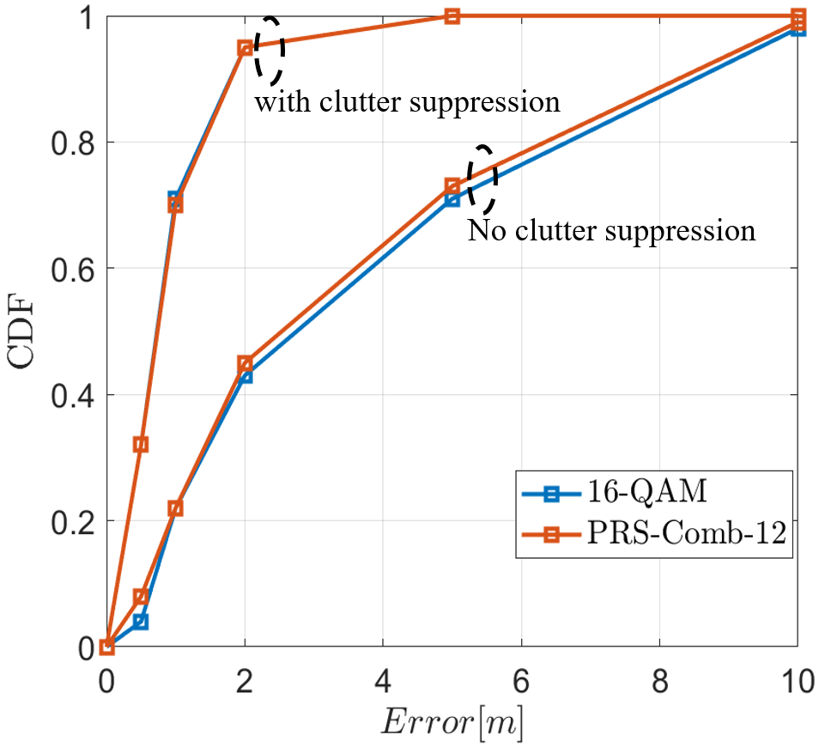
Figure 7 Positioning performance of single symbol transmission of DL data within the full band vs. PRS (Comb 12)-based positioning.
Proposal 14. RAN1 to study potential scenarios and feasibility for data-assisted sensing, wherein a transmitted physical channel is used for sensing by a sensing receiver
Proposal 15. RAN1 to study enhancements/adjustments, including sensing measurements and MIMO operation, for the TRP-based target positioning based on PDSCH transmission

Sensing assisted communication
Sensing assisted communication includes all scenarios, wherein the sensing operation can assist in facilitating and/or improving communication-specific KPIs. In particular, we envision the following possibilities for sensing assisted communication, including environment-centric, target centric, and signal central sensing assisted communication.
Environment-centric sensing-assisted communication.
Environment-centric sensing-assisted communication includes the scenarios where sensing operation assists to obtain information from the surrounding environment and thereby facilitates a rich prior information on the channel and the expected radio environment. The obtained prior information can be hence utilized for the purpose of enhancing/optimizing communicating performance, including beam management, handover, etc. examples of this case include sensing-assisted development of a network digital twin, at least by identifying the main building structures in an urban environment. It is worth mentioning that study of sensing-assisted communication via accumulation of RF environment map, leads to additional study efforts specific to channel modeling (e.g., modeling walls and other related structures as sensing target with additional modeling accuracy), as well as the study/evaluation of how and how much the specific digital twin information can assist communication performance.
Observation 11. Environment-centric sensing-assisted communication requires additional study efforts in terms of channel modeling as well as the identification & evaluation of the additional environment information types on the communication performance enhancements
Target-centric sensing-assisted communication.
As described in Subsection 3.3.2, when the UE device is further attached to a physical object, the sensing of the said sensing object (e.g., sensing of the reflection of the DL signals towards the said UE), would inform network of the UE’s position, mobility, as well as the potential link conditions (e.g., LOS/NLOS, blockage, pathloss, etc.) with respect to existing radio nodes/TRPs. This scenario is distinct from the above environment-centric assistance, as the target of the sensing operation is not the background/environment channel, but the UE it self (as a physical passive object co-located with the said UE).
Signal-centric sensing-assisted communication.
The signal-centric assistance includes all instances wherein a sensing-specific signal can be opportunistically used for communication purposes, e.g., to convey useful information, or for facilitating CSI measurement by a UE not necessarily associated with the sensing operation. As such, it is of interest to identify relate scenario and use-cases wherein such sensing signal re-use can be gainful.
Observation 12. When a UE device is attached to a physical object, sensing of the attached passive object facilitates observing the UE’s mobility, blockage condition, and potential link LOS/NLOS or pathloss status towards the involved TRPs.
Proposal 16. RAN1 to consider the following categories for identifying scenarios of sensing-assisted communication:
Target centric sensing assistance, wherein the sensing measurements conducted from the passive object attached or collocated with a UE reveal communication relevant information of UE
Environment centric sensing assistance, wherein the sensing measurements are used to obtain information of the static and/or dynamic components of the communication channel
Signal centric sensing assistance, wherein the sensing signals are opportunistically used for obtaining communication relevant CSI measurements
Proposal 17. RAN1 to study at least the measurements and physical layer procedures for performing target-centric sensing assistance
In such scenarios where a UE device is further attached to a physical object, the participation of the said attached UE in the measurement process can be complemented with the sensing measurements. In particular, the positioning measurements representing the UE position (e.g., ToF measurements) can be augmented with the sensing measurements representing the scattering point of the sensing paths located at the physical attached object.
Observation 13. When a UE device is attached to a physical object, a (e.g., DL) signal received by the UE may be utilized for positioning or timing measurements, whereas the reflection of the said signal can be simultaneously used for sensing measurements by neighbouring UEs and/or TRPs.
Proposal 18. RAN1 to study scenarios and feasibility of joint sensing and positioning measurement combining, at least including combining of UE positioning measurements and sensing measurements of a target attached to the said UE

Sensing measurements and report
In RAN1#124-bis, it is agreed to study the measurement definitions and levels for the both TRP-side and UE side measurements, at least including impacts of non-ideal factors [Appendix B, Agreement#3]. Among others, the impairments of timing and/or carrier frequency mismatch can be detrimental to the geometry-related estimates, as they directly translate into delay/distance or velocity/doppler estimation error.
In order to compensate for such mismatches, the measurement definitions can be adopted with natural resilience to the timing and doppler mismatches or a sensing Tx and/or sensing Rx node. This includes at least the round-trip type measurements, as well as differential measurements at which the sensing measurement is taken as a difference according to a reference measurement, such that additive error appears as a constant error term and hence compensated due to the inherent subtraction. The measurement reference of a sensing measurement type can be envisioned as any of a reference path, e.g., measurement of a sensing path relative to a reference path, a reference time, e.g., measurement of a sensing path at a first time relative to a second time, or a sensing Tx/Rx node, e.g., measurement of a scattering point performed via a first sensing Tx or Rx node, relative to the measurement of a second sensing Tx or Rx node.
Proposal 19. RAN1 to study round-trip measurements of a sensing path between a sensing Tx and sensing Rx nodes in both delay and doppler domain as a mechanism to compensate the time/frequency/phase mismatches.
Proposal 20. RAN1 to study differential measurement to compensate for inter node and intra node frequency, time and/or phase mismatches, including at least differential measurements of a sensing path or point, according to
a reference time, wherein sensing measurement includes difference of a sensing measurement quantity obtained at a measurement time and a reference time
a reference path, wherein sensing measurement includes difference of a sensing measurement quantity obtained at a sensing path and a reference path
a reference node, wherein sensing measurement includes difference of a sensing measurement quantity obtained at a sensing path and a reference path

Beam management for sensing
For the sensing operations, it is of interest to perform sensing transmission and/or reception to illuminate a potential sensing target area or a sensing target, which can be inherently mobile. In particular, once a sensing target and/or path is detected by a sensing entity the following sensing, positioning, tracking measurements can be enhanced by utilizing transmission and/or reception beams particularly tuned to the said target.
Observation 14. Upon detection of a sensing target and/or a sensing path at a sensing entity, it is of interest specifically adjust the spatial transmission and reception characteristics to the said sensing path/target direction.
Proposal 21. RAN1 to consider association mechanisms between a Tx/Rx beam and a sensing path and/or sensing target

Sensing node selection
In some scenarios, the selection of a sensing entity to act as sensing Tx and/or sensing Rx node is highly situational and may not be purely determined via the nodes position or situation-independent capabilities (e.g., MIMO processing capabilities, support of different frequency bands). For instance, when one or more UE devices are expected to act as sensing Tx and/or sensing Rx nodes for measurements with unknown antenna observability and orientation relative to the desired sensing area, the determination of the properly situated sensing entities is not primitive. In such scenarios, the selection of the radio nodes can be performed via specific measurements relaying on the apriori known target conditions. More specifically, when presence of a sensing target within an expected/desired sensing area is known at a particular instance, the measurement results of a group of candidate sensing Rx nodes with known/sufficient capability will assist selection of the sensing entities capable of observing/sensing within the said desired sensing area in the future instances.
Observation 15. In some scenarios, the node’s ability to perform sensing of a desired sensing target area can be situational and not known apriori. As such, the selection of the appropriate sensing entities can be performed via measurements conducted by the said sensing entity when the sensing target presence is known as a ground truth.
Proposal 22. RAN1 to consider selection of sensing nodes, based on the sensing measurements from an apriori known environment/target condition as a ground truth

Conclusion
The list of the main observations and proposals within this paper are summarized as following:
General Considerations
Observation 1. There is a great motivation to align the physical layer operation and requirements of sensing to that of the communication system, given the inherent synergy, design & implementation simplicity, as well as communication centric prioritization of the system behaviour.
Proposal 1. RAN1 to consider a sensing operation that re-uses, to the extent possible, the underlying communication entities, signals and procedures, wherein the sensing specific enhancements and optimization are introduced when necessary and justified.
Observation 2. Different sensing modes imply different physical layer operation and limitations, as well as the integration aspects with communication, wherein the measurement process involves considerations of different radio capabilities, signal transmission, and measurement processing and reporting capability.
Proposal 2. Consider the physical layer aspects for integration of sensing and communication, separately for different sensing modes
Observation 3. The involvement of UE as part of a sensing scenario is envisioned, at least considering UE operation as a sensing Tx/Rx or measurement node, as a node relatively defining the sensing area (e.g., as center of a sensing area), and the UE attached/co-located with a sensing target object (e.g., a vehicle UE attached to a vehicle body to be sensed).
Proposal 3. Consider at least the following three UE involvement for integration of sensing with other system operations and services (communication, positioning)
- UE as a sensing Tx/Rx or measurement node
- UE as a defining node of a sensing area
- UE as an attached connected device to a sensing target object

Reference signal for sensing
Proposal 4. RAN1 to study sensing-specific reference signal design separately for the symbols dedicated to sensing, as reserved/dedicated sensing resource, and symbols utilized jointly for sensing and communication purposes.
Pulse signal
Observation 4. Generation of pulse-signal for sensing is of interest for resolving limitations of dynamic range, when the target channel is of a substantial delay difference as well as lower energy compared to the direct/background paths
Proposal 5. RAN1 to study OFDM-based pulse-signal generation for sensing from the perspective of resource multiplexing and communication coexistence, both within dedicated sensing symbols and within symbols jointly used for data transmission
Comb RS pattern for sub-symbol periodicity
- Proposal 6. RAN1 to study OFDM-based sensing signal generation according to a Comb structure with intra-symbol cyclic property to achieve larger CP behaviour.
Multi-resolution enhancement
Observation 5. The large sensing observation time, required for high resolution doppler estimation for path separation, together with the needed pulse transmission interval for keeping doppler estimation within an unambiguous region, when assuming a uniform resource pattern, leads to a large resource overhead in the time-domain
Observation 6. Similarly, the large sensing signal bandwidth, required for high accuracy delay estimation, together with the needed maximum inter-RE separation for keeping delay estimation within an unambiguous region, when assuming a uniform resource pattern, leads to a large resource overhead in the frequency domain
Proposal 7. RAN1 to study non-uniform resource patterns, in both time and frequency for a sensing RS including at least the following methods
Defining native time-frequency patterns supporting multi-resolution behaviour
Generating a sensing RS time-frequency resource pattern as a combination of multiple existing RS patterns
Reuse of existing communication RS, e.g., CSI-RS, for sensing
Observation 7. For the sensing modes including TRP as a sensing Tx node, pure reuse of existing CSI-RS/TRS may be insufficient for high performance sensing/positioning use cases at least due to limited time-domain density.
Proposal 8. For the sensing modes including TRP as a sensing Tx node, consider CSI-RS and TRS as the basis for sensing RS design, at least considering enhancements in time-domain behavior (e.g., density).

Resource multiplexing
Observation 8. For a UMa scenario with ISD = 500m, the link coverage for a monostatic TRP for UAV sensing extends beyond the assumed cell boundaries, and hence the mutual impact of sensing signal to other sensing signal and/or communication signals needs to be understood and controlled.
Proposal 9. RAN1 to consider multiplexing schemes among the sensing signals and/or communication signals transmitted by one or multiple sensing entities needs to be considered, at least via a combination of one or more of the TDM, FDM, SDM, CDM schemes.
Proposal 10. RAN1 to consider multi-port sensing RS multiplexing with flexible cover-code configurations, at least supporting TD-OCC length = 1 (for high doppler scenarios), FD-OCC length = 1 (for large propagation delay scenarios) and TD-OCC length = 1, FD-OCC length = 1 (for jointly larger doppler and propagation delay).
Observation 9. Due to a large sensing time needed to obtain sufficient doppler resolution, the sensing signal may be spread over a large volume of transmission resources, with a reduced sensing transmission power, facilitating power-domain superimposed transmission with data
Proposal 11. RAN1 to consider the scenarios and methods to facilitate power domain superimposed sensing transmission to reduce time/frequency resource overhead for sensing
Proposal 12. RAN1 to consider non-orthogonal multi-port sensing RS multiplexing methods, including non-orthogonal cover-codes as well as sequence domain superimposition for sensing
Communication-assisted sensing
Observation 10. The associated DL or UL physical channels to a UE, when present, can be opportunistically used to obtain sensing measurements for proximity sensing use-cases.
Proposal 13. RAN1 to study feasibility and potential enhancements to the sensing measurements based on physical data or control channels for proximity sensing use-cases, at least from the perspective of the resource pattern, measurement behaviour and MIMO operation.
Proposal 14. RAN1 to study potential scenarios and feasibility for data-assisted sensing, wherein a transmitted physical channel is used for sensing by a sensing receiver
Proposal 15. RAN1 to study enhancements/adjustments, including sensing measurements and MIMO operation, for the TRP-based target positioning based on PDSCH transmission
Sensing assisted communication
Observation 11. Environment-centric sensing-assisted communication requires additional study efforts in terms of channel modeling as well as the identification & evaluation of the additional environment information types on the communication performance enhancements
Observation 12. When a UE device is attached to a physical object, sensing of the attached passive object facilitates observing the UE’s mobility, blockage condition, and potential link LOS/NLOS or pathloss status towards the involved TRPs.
Proposal 16. RAN1 to consider the following categories for identifying scenarios of sensing-assisted communication:
Target centric sensing assistance, wherein the sensing measurements conducted from the passive object attached or collocated with a UE reveal communication relevant information of UE
Environment centric sensing assistance, wherein the sensing measurements are used to obtain information of the static and/or dynamic components of the communication channel
Signal centric sensing assistance, wherein the sensing signals are opportunistically used for obtaining communication relevant CSI measurements
Proposal 17. RAN1 to study at least the measurements and physical layer procedures for performing target-centric sensing assistance
Observation 13. When a UE device is attached to a physical object, a (e.g., DL) signal received by the UE may be utilized for positioning or timing measurements, whereas the reflection of the said signal can be simultaneously used for sensing measurements by neighbouring UEs and/or TRPs.
Proposal 18. RAN1 to study scenarios and feasibility of joint sensing and positioning measurement combining, at least including combining of UE positioning measurements and sensing measurements of a target attached to the said UE
Sensing measurements and report
Proposal 19. RAN1 to study round-trip measurements of a sensing path between a sensing Tx and sensing Rx nodes in both delay and doppler domain as a mechanism to compensate the time/frequency/phase mismatches.
Proposal 20. RAN1 to study differential measurement to compensate for inter node and intra node frequency, time and/or phase mismatches, including at least differential measurements of a sensing path or point, according to
a reference time, wherein sensing measurement includes difference of a sensing measurement quantity obtained at a measurement time and a reference time
a reference path, wherein sensing measurement includes difference of a sensing measurement quantity obtained at a sensing path and a reference path
a reference node, wherein sensing measurement includes difference of a sensing measurement quantity obtained at a sensing path and a reference path
Beam management for sensing
Observation 14. Upon detection of a sensing target and/or a sensing path at a sensing entity, it is of interest specifically adjust the spatial transmission and reception characteristics to the said sensing path/target direction.
Proposal 21. RAN1 to consider association mechanisms between a Tx/Rx beam and a sensing path and/or sensing target
Sensing node selection
Observation 15. In some scenarios, the node’s ability to perform sensing of a desired sensing target area can be situational and not known apriori. As such, the selection of the appropriate sensing entities can be performed via measurements conducted by the said sensing entity when the sensing target presence is known as a ground truth.
Proposal 22. RAN1 to consider selection of sensing nodes, based on the sensing measurements from an apriori known environment/target condition as a ground truth

References
- 3GPP TR 22.837, “Feasibility Study on Integrated Sensing and Communication (Release 19)”, V19.2.0 (2023-12).
- 3GPP TS 22.137, “Service requirements for Integrated Sensing and Communication; Stage 1 (Release 19)”, V1.1.0 (2023-12).
- RP-251861, “New SID: Study on Integrated Sensing And Communication (ISAC) for NR”, AT&T (Moderator)
- 3GPP TR 38.901, “Study on channel model for frequencies from 0.5 to 100 GHz”
- 3GPP TR 38.765, Study on Integrated Sensing And Communication (ISAC) for NR (Release 20)
- R1-2601458, On ISAC performance evaluations and assumptions (Lenovo), 3GPP TSG RAN WG1 #124, Gothenburg, SE, Feb. 9th ~ 13th, 2026
- 3GPP TR 38.802, “Technical Specification Group Radio Access Network; Study on New Radio Access Technology, Physical Layer Aspects” (Release 14)”
- 3GPP TR 38.858, “Technical Specification Group Radio Access Network, Study on Evolution of NR Duplex Operation (Release 18)”
- R1-2502587, „Discussion on Channel Modelling for ISAC“ (Lenovo)
- RP-251881, “New SID: Study on 6G Radio”, 3GPP TSG RAN Meeting #108, Prague, Czech Republic, June 9-13, 2025
- R1-2602592, “Summary #4 on integration with communication for ISAC”, 3GPP TSG RAN WG1 #124bis, Malta, MT, April 13th ~ 17th, 2026.
- R1-2604232, “Views on waveform and frame structure for ISAC”, Lenovo, Dalian, China, May. 18th ~ 22th, 2026.

Appendix A – Example communication assisted sensing operation in an InF

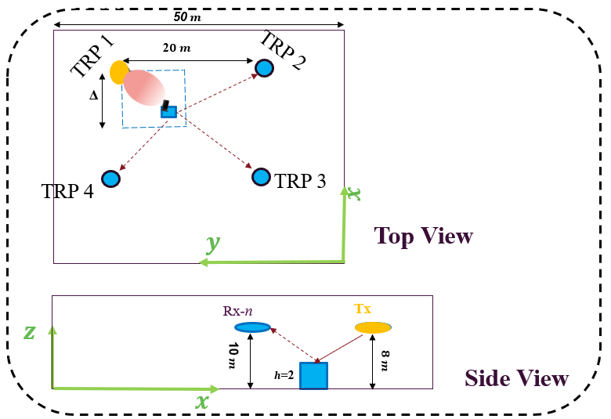
Figure 8. Evaluation scenario of UAV sensing, including sensing Tx/Rx (TRPs) and a UE attached to an AGV as a sensing target

Table 1. Summary of initial evaluation parameters for TRP-based AGV sensing
Parameter | Value
Scenario | InF
ISD | 20m
Hall dimension | 120 x 50 x 10
Obj dim | [0.3, 1.3, 1.7] m
Tx power | 29 dBm
Tx/Rx (TRP) height | 25
Tx/Rx (TRP) Orientation | [0, 90, 0]
Element radiation pattern | According to 38.901
Tx/Rx (TRP) Array size | [2 2 2 1 1]
Fc, SCS | (28GHz, 120 kHz)
BW | 400 MHz
Sensing time/overhead | 1 symbol, full resource overhead for sensing with clutter suppression (option 1)
$$NF$$ | 5 dB
$$N_{0}$$ | -174 [dBm/Hz]
TRP height | 10 m

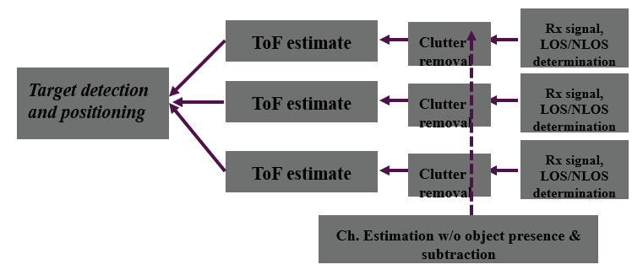
Figure 9. High level sensing process, including reception by neighbouring TRPs, clutter removal, measurement including path-energy detection and ToF determination, and target positioning at a fusion center (e.g., at the SF)

Applying the sensing processing as depicted in Figure 10 and following the setup defined in Table 1, the positioning estimation error of the data and PRS-based sensing is depicted in Figure 11 below, assuming the data transmission occupying the full-channel with BW= 400MHz.


Figure 10 Positioning performance of single symbol transmission of data within a full band vs. PRS (Comb 12)-based positioning.

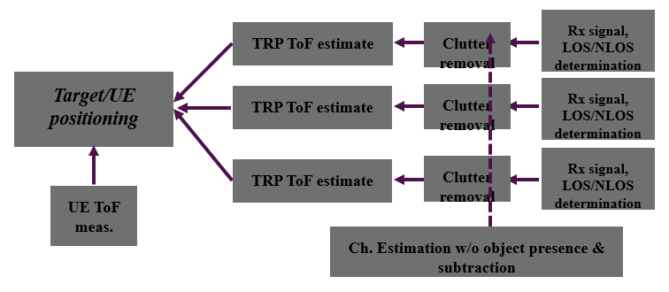
Figure 11. High level sensing process, including reception by neighbouring TRPs, clutter removal, measurement of the UE (positioning) is combined with TRP-based sensing measurements for enhanced positioning estimation.

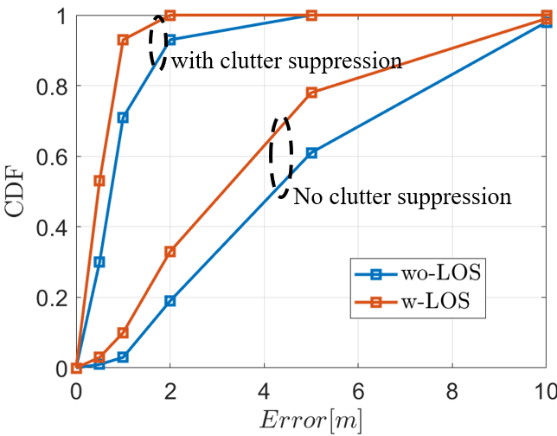
Figure 12 sensing-assisted positioning enhancements. The same scenario and measurement setup as defined above, with the inclusion of the DL ToF measurement of the LOS path at the UE combined with the TRP sensing measurements

Appendix B – Agreements

Agreement #1:
- On RS for ISAC, study at least the following aspects, considering sensing performance, resource overhead and impact to communication
  - RS for communication is reused for sensing
  - Enhanced RS for sensing, taking reuse of RS for communication as starting point
    - Note: Part of or all of the RS may be used for communication purpose, and it does not mean the final decision on whether the enhanced RS is used for communication purpose is to be made in this agenda.
  - Dedicated RS for sensing

Agreement #2:
- Study RE patterns of RS for sensing, considering sensing performance, resource overhead and impact to communication
- Note: enhancements on RS sequence if any will be discussed in agenda 10.8.3

Agreement #3:
- On measurement for ISAC, study at least the following aspects.
  - Measurement definitions/levels for TRP-side measurement, taking the measurement Levels studied in NR ISAC as starting point
  - Measurement definitions/levels for UE-side measurement
  - Impacts of non-ideal factors on measurement
  - Other aspects are not precluded
  - Note: this discussion may or may not mean there is specification impact

Agreement #4:
- On measurement report for ISAC, study at least the following aspects and applicable scenarios (e.g., sensing modes, targets, etc.) from RAN1 perspective.
  - Measurement reporting mechanism from UE
    - Option 1A: The UE measurements and/or assistance information if needed from UE can be directly sent to aNB
    - Option 1B: The UE measurements and/or assistance information if needed from UE can be sent to SF
  - Measurement reporting mechanism from aNB
    - Option 2A: The aNB measurements and/or assistance information if needed from aNB can be directly sent to UE
    - Option 2B: The aNB measurements and/or assistance information if needed from aNB can be sent to SF
  - The study may require cross-WG coordination.
  - Note: combination of multiple options is not precluded.
  - Note: measurements in each option may be different

Agreement #5:
- On measurement report for ISAC, study impacts from at least the following aspects from RAN1 perspective
  - Measurement reporting mechanism
    - E.g., Periodic, semi-persistent, aperiodic, event-triggered report as starting point
    - Reporting signaling e.g., L1, L2, higher layer, etc.
  - Other aspects are not precluded
The study may require cross-WG coordination.

